This year, during our 41st Annual Flywheel Reunion, we will be hosting our 4th Annual Silent Auction Fundraiser.

All funds raised from the silent auction will go to benefit local’s in the community during the Christmas season.

This silent auction can't happen without your support. Please consider supporting this silent auction by donating gift certificates, merchandise or services. In exchange, you will receive some excellent community exposure and advertising. Your name and a brief description of your goods will be posted next to your donation.

A donation form for the silent auction is below Simply fill it out and send it back to us. Please bring your donation to Floral Hall when you check in for the event. If you are unable to attend the event but would still like to donate, you may send your donations by mail to the address on this form.

Thank you in advance for considering this request and for supporting the Macon County Flywheel & Collectibles Club.

Macon County Flywheel &

Collectible Club

41st Annual Old Time Flywheel Reunion
Krystal Williams
C/O Macon Co. Flywheel and Collectables Club
307 Pearl Street
Macon, Mo 63552

Please make checks payable to
Macon Co. Flywheel

July 22, 23, 24, 25 2021

Toy Show &
Liability Waiver

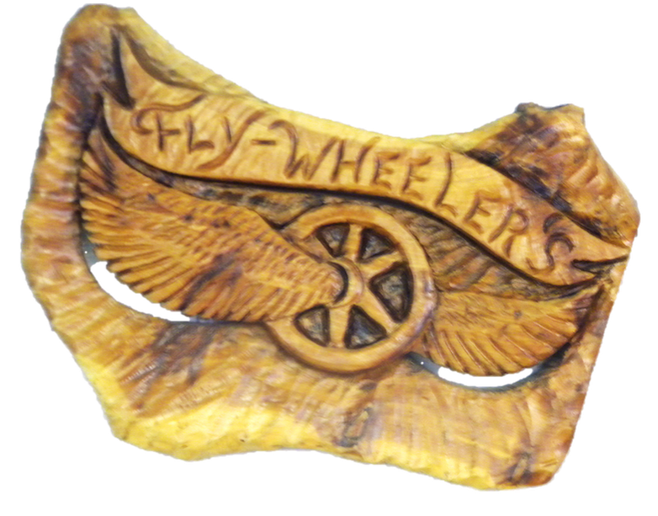

Approximate Value $ ___________

Donor Name: ______________________________________

Description of item you are donating:

Macon Co. Fairgrounds Park
(Hwy 63 S.)
Macon, Missouri

Toy Show Vendor Agreement
This agreement is between the Toy Show vendor for the Macon County Flywheel and Collectible Club.

Name |  |  |  |  |  | Business Name
Contact Name |  |  |  | Phone Number |  |  |  | Email Address (if applicable)
Address |  |  |  |  |  | City |  |  |  | State |  | Zip

Please provide a brief description of your product(s):

Set Up and Tear Down  Set up time begins Thursday afternoon prior to the toy show; however, you can set up or tear down any time during the two-day show. If assistance is needed, please do not hesitate to ask. We do ask that if you need assistance setting up or tearing down that you request assistance enough time in advance to ensure we have enough people available to assist. NOTE: The Park charges $20 per night for camping they will collect this charge | Table Selection  - One (1) Table $20  - Two (2) Tables; $35  - Three (3) Tables; $45  - Four (4) Tables; $50  - Five (5) Tables; $55  - Additional Tables - $5 per table (please leave a note of number of tables)

Liability Waiver  I, ___________________________________ , fully understand that the Macon County Flywheel and Collectible club and/or any person staffed or acting on their behalf will not be held responsible for any loss, damage, or personal injury of any kind during the duration of the Flywheel Reunion. I have read and agree to this provision as witnessed by my signature below.  Signature Date Signed | Emergency Contact Information  Contact Name Relationship  Contact Number  Contact Name Relationship  Contact Number

